

**Confidence Ruler**

**(Ring)**

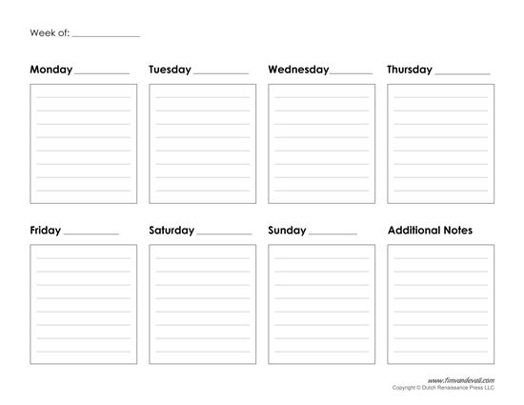

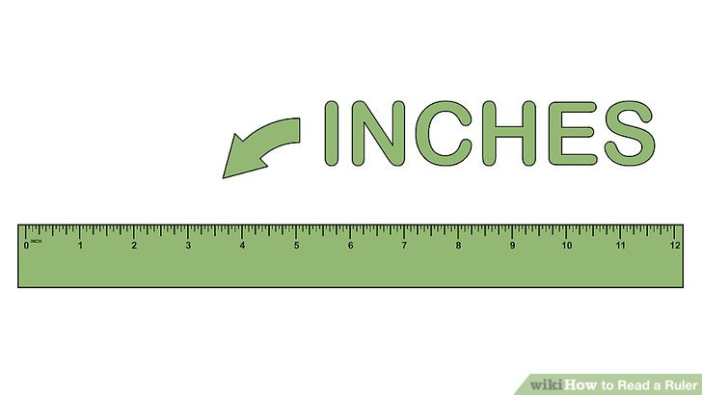**How confident are you that you will be able to keep the ring in your vagina all the time?**

**Extremely confident**

**Not confident at all**



**Confidence Ruler**

**(Tablet)**



**How confident are you that you will be able to take**

**the PrEP tablet every day?**

**Not confident at all**

**Extremely confident**